Sumit Vadaviya

Camunda BPM Expert, Corporate Trainer

Email : sumit.vadaviya@trainosoft.com

I

n this session we will have quick overview of camunda cockpit web application.

Camunda Web Application Cockpit

**Camunda web applications**

* + Tasklist
  + CockPit
  + Admin
* **Cockpit**

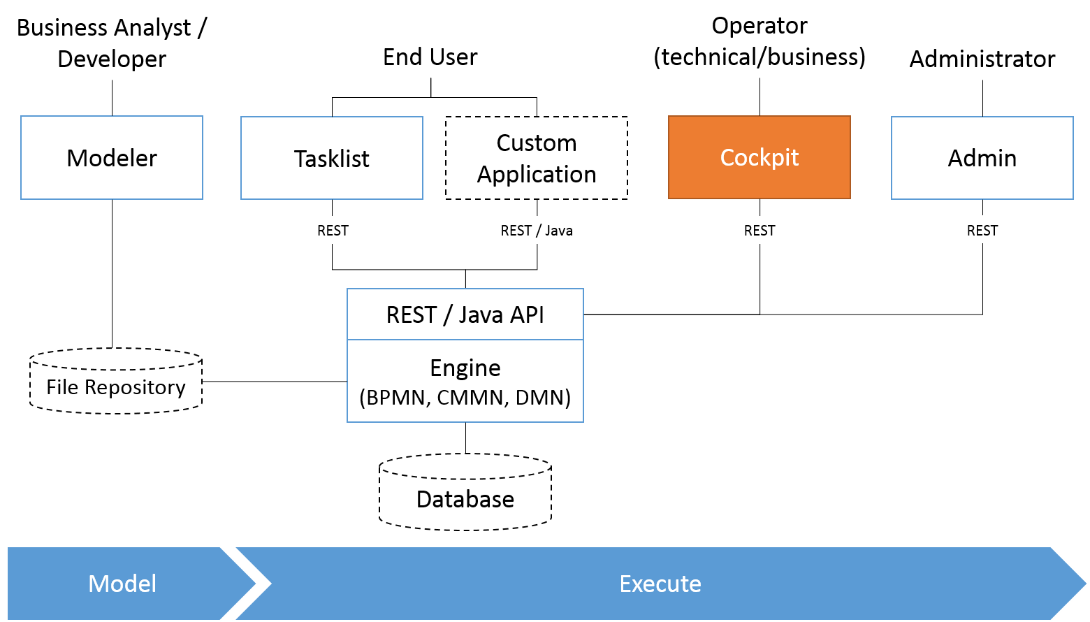

**2. Cockpit**

* With Camunda Cockpit you can monitor workflows and decisions in production to discover, analyze and solve technical problems.
* Cockpit provides a dashboard of running BPMN process models that allows you to quickly see what’s going on and find specific process instances based on different criteria.
* Cockpit provides monitoring and analyzing data. With this you can also make changes in the Decision tables even at the process runtime.
* Cockpit allows you to create custom reports for the deployed processes. Allows searching for the running, completed processes or the operations.

**Landing screen**

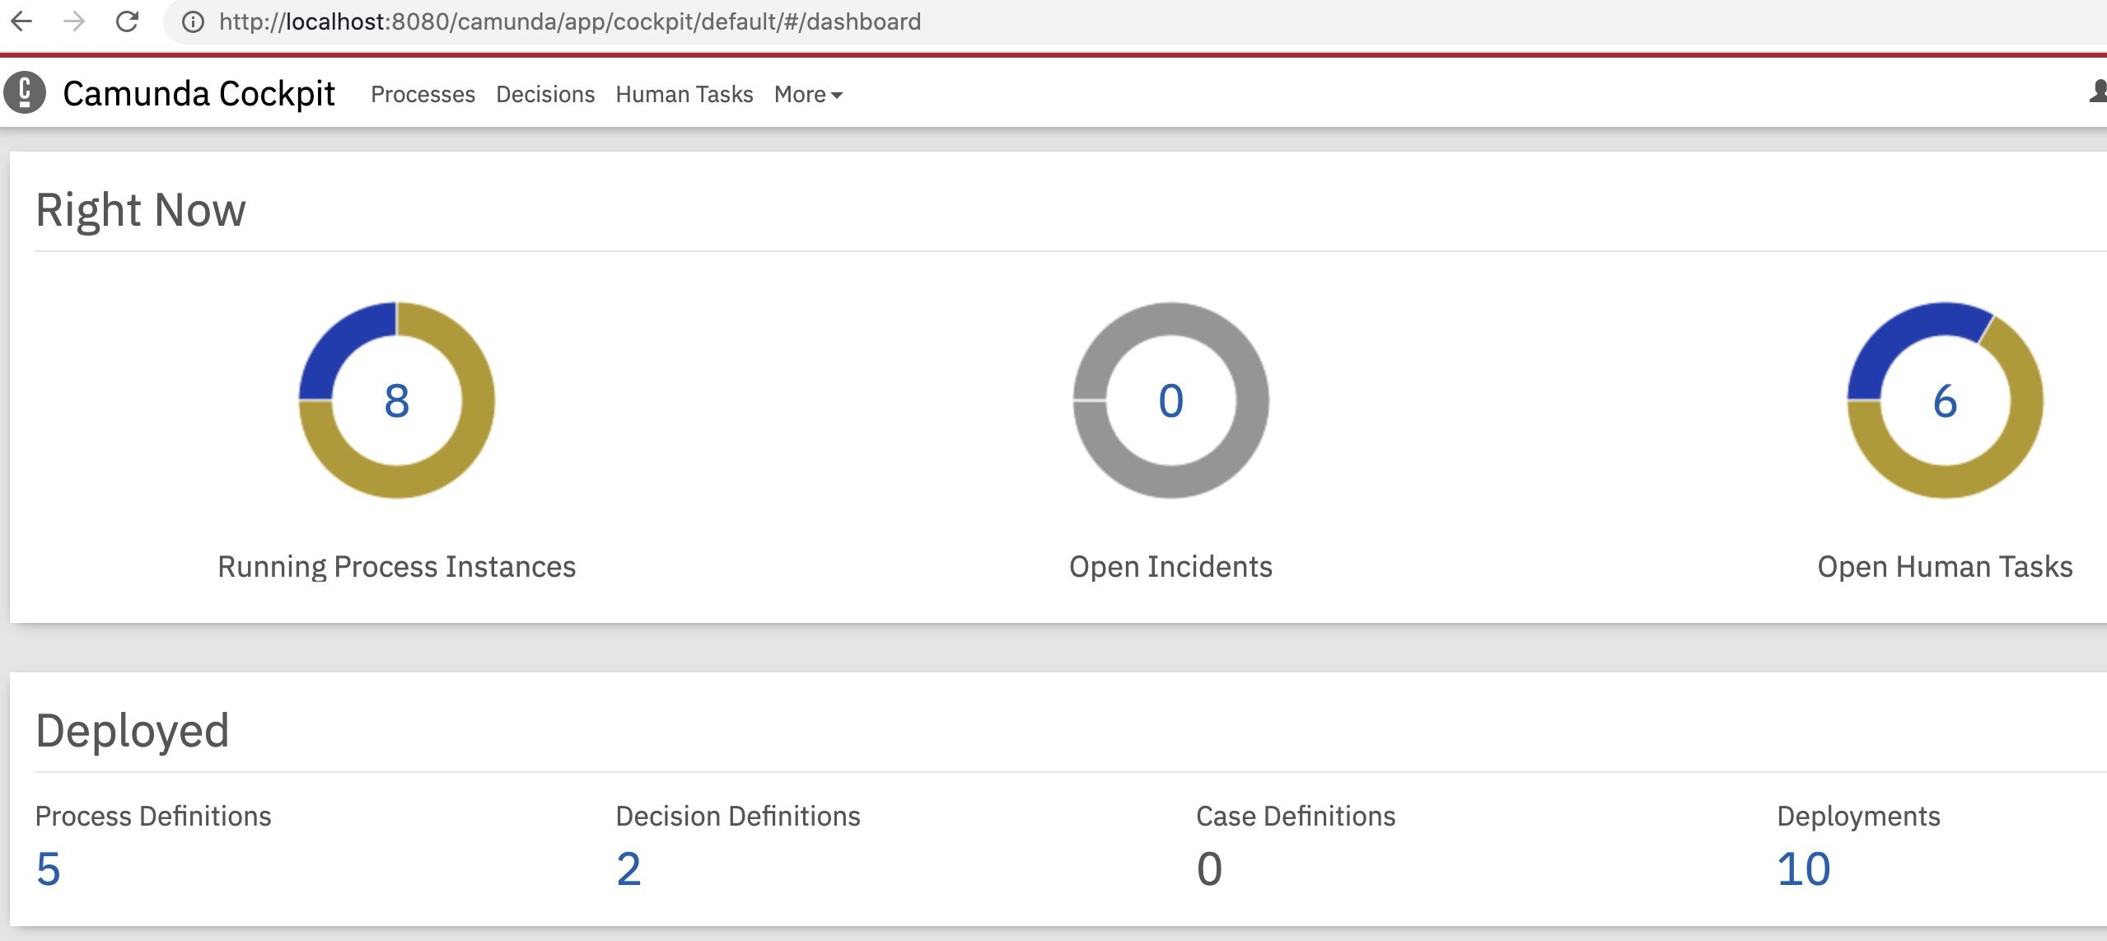

* In the Right Now section, You can see number of running process instances, open incidents and open human tasks.
* In the Deployed section, You can see number of deployed process definitions, decision definitions, case definitions and deployments.
* **Running Process Instances:** On clicking running process instances, you can see running process instances for each deployed process definition.

View running process instances in list mode.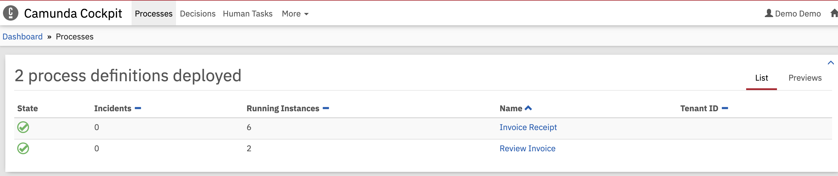

View running process instances in previews mode.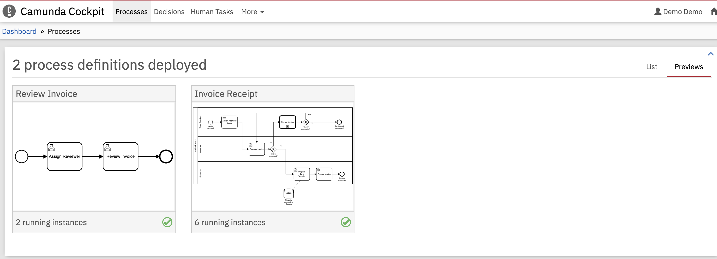

* **Open Human Tasks :** On clicking Open Human Tasks, you can see open human tasks.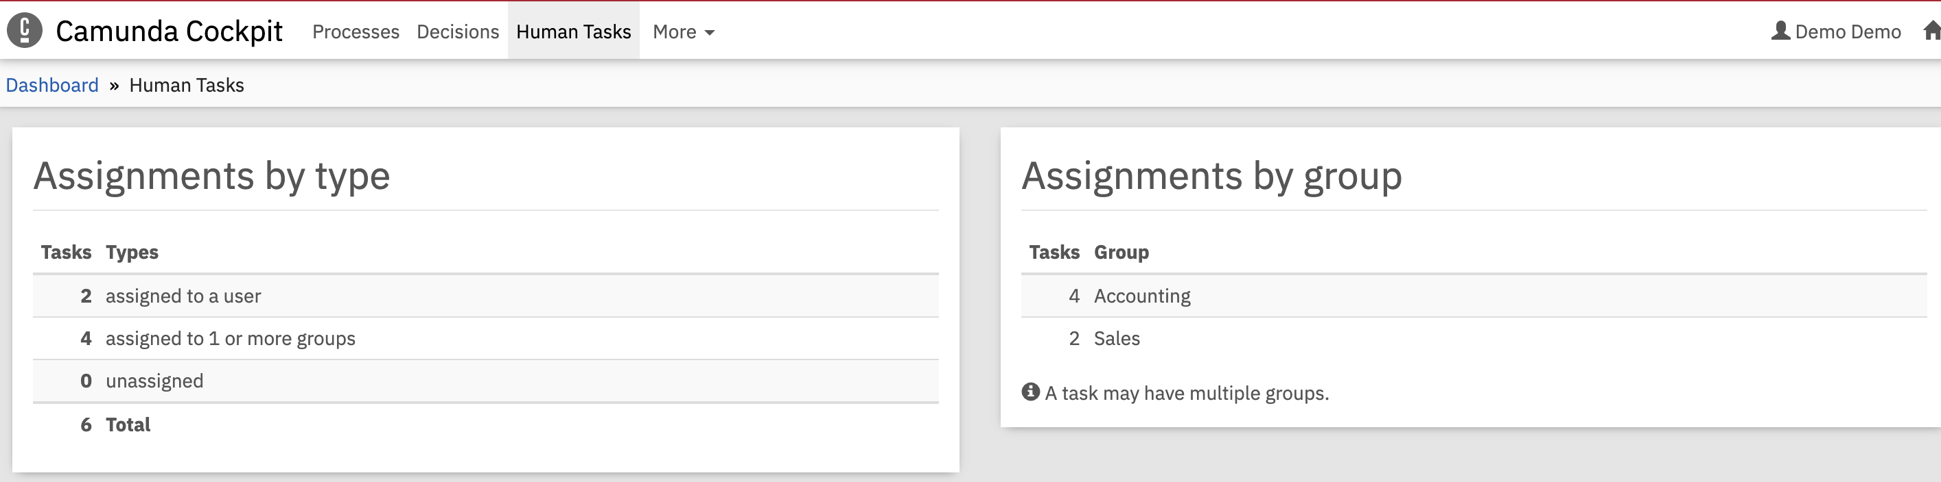
* **Deployed Process Definitions :** On clicking Deployed process definitions, you can see deployed process definitions.

View deployed process definitions in list mode

View deployed process definitions in previews mode

* **Deployed Decision Definitions :** On clicking Decision Definitions, You can see deployed decision definitions.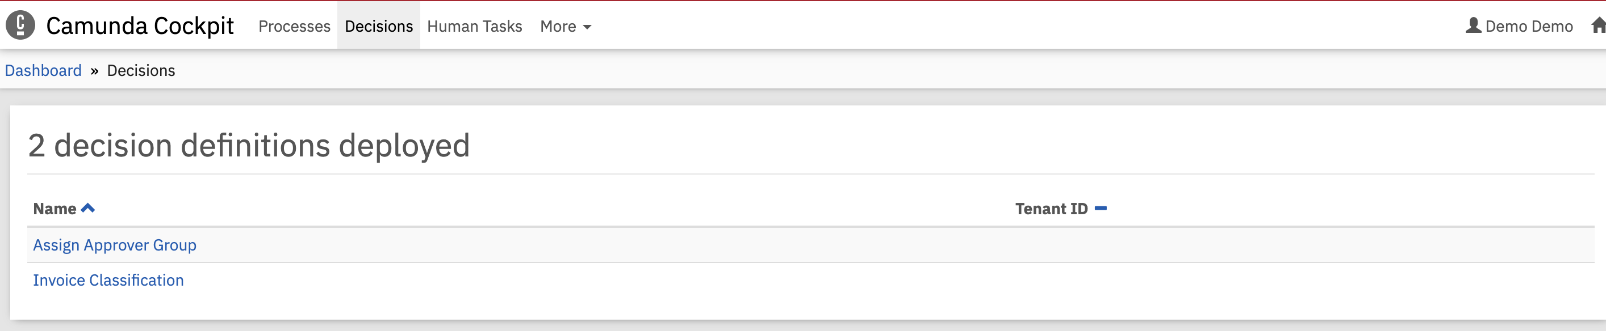
* **Deployed Deployments :** On clicking Deployments, You can see deployed deployments.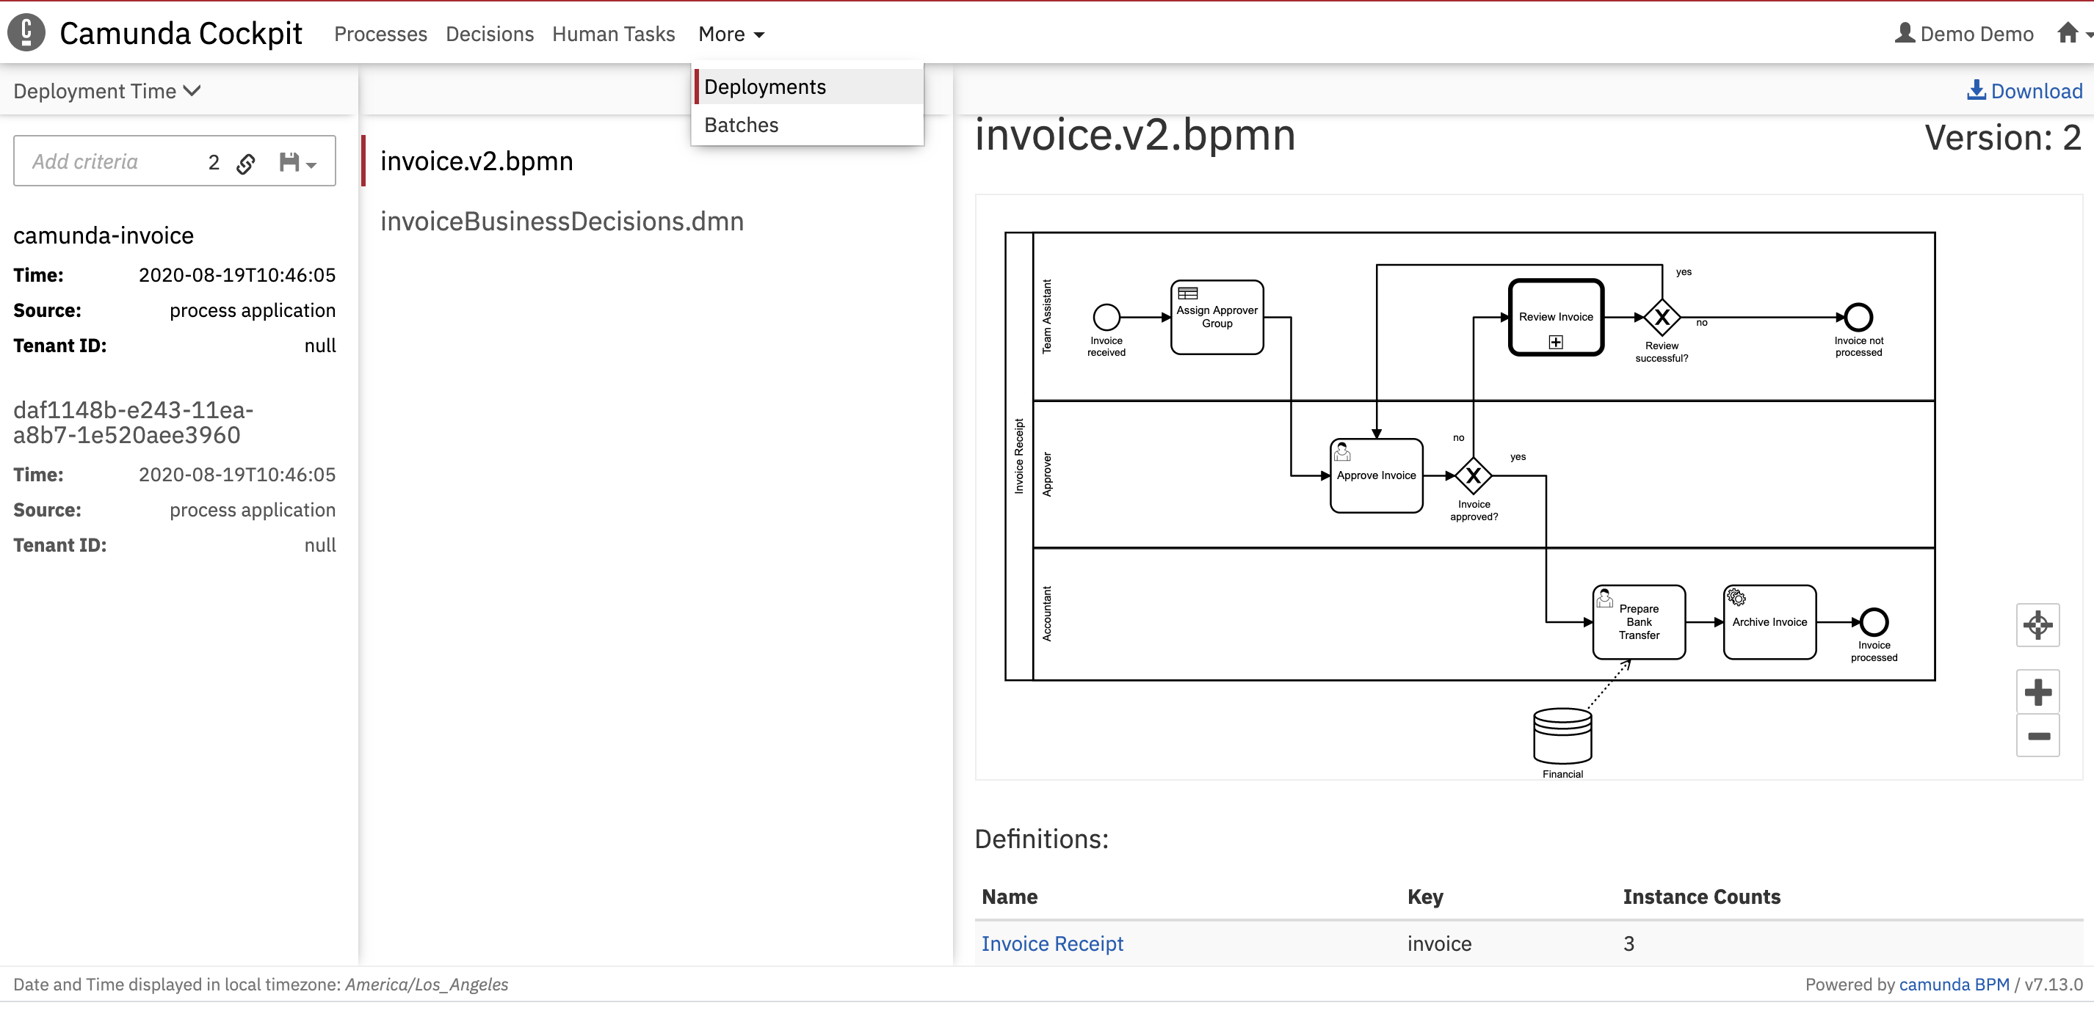

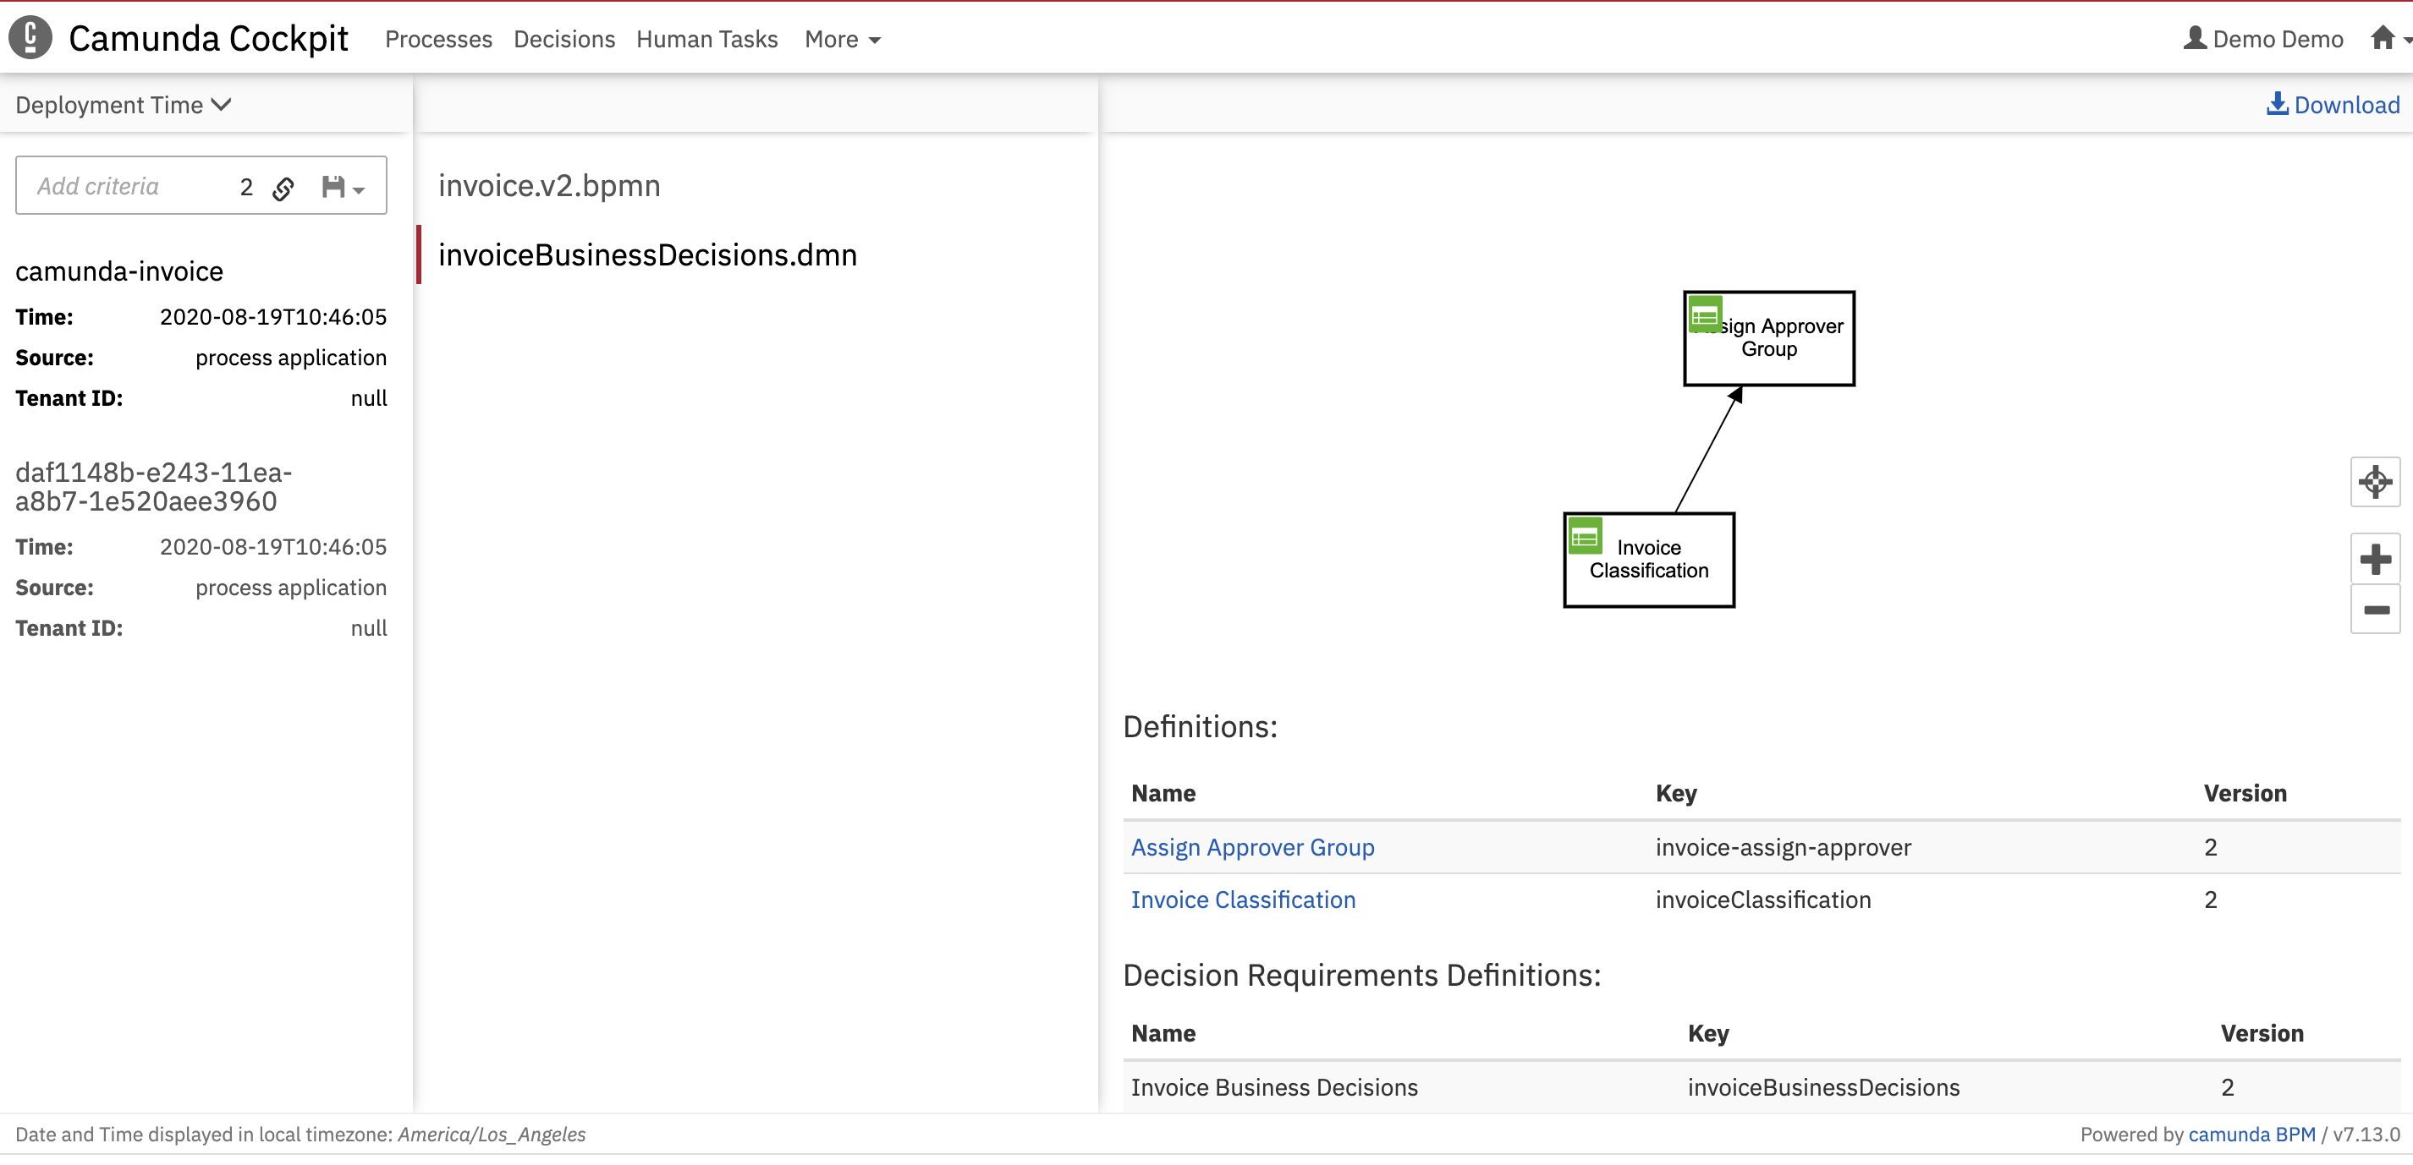

* **Detailed view and edit process instances**

1. Click on Processes menu.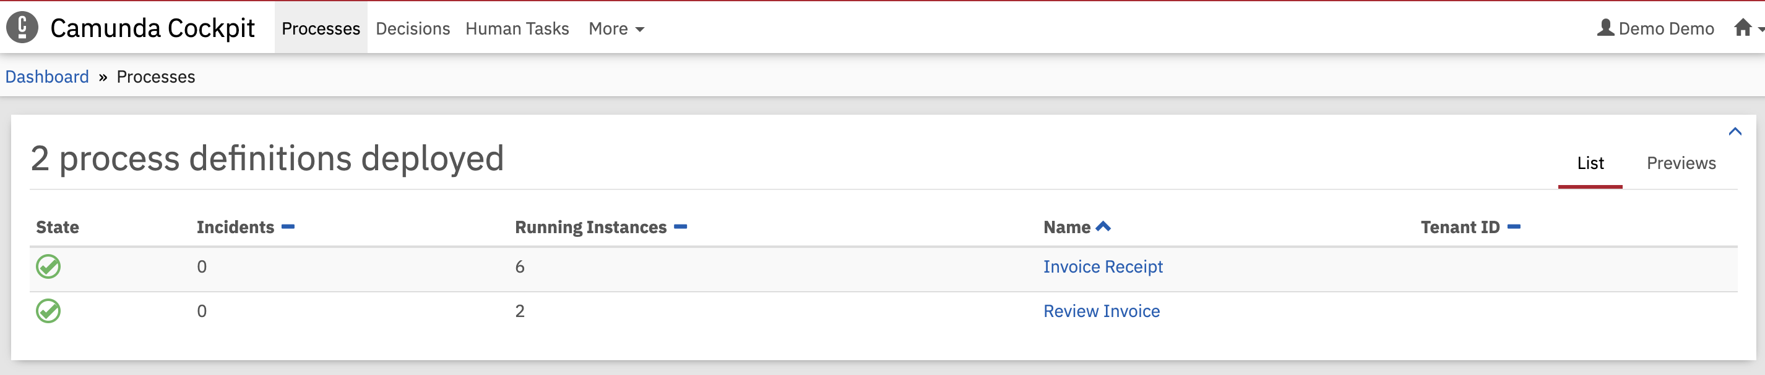
2. Click on processes definition name Invoice Receipt. You will see running process instances for process definition Invoice Receipt.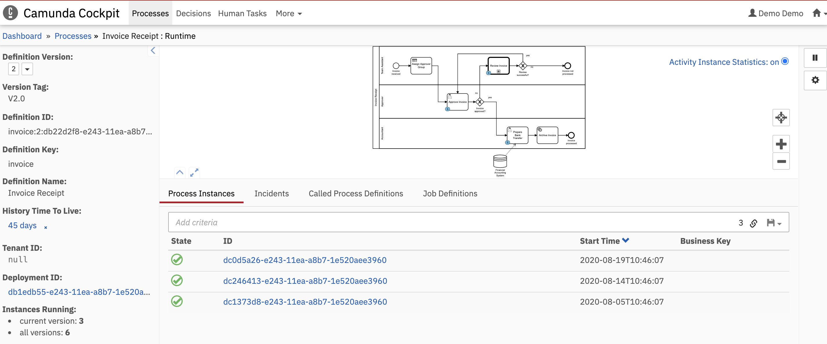

* You can see 3 process instances created for process definition Invoice Receipt with version 2.
* Process instances can be seen by version. So let change the version from default 2 (latest version ) to 1.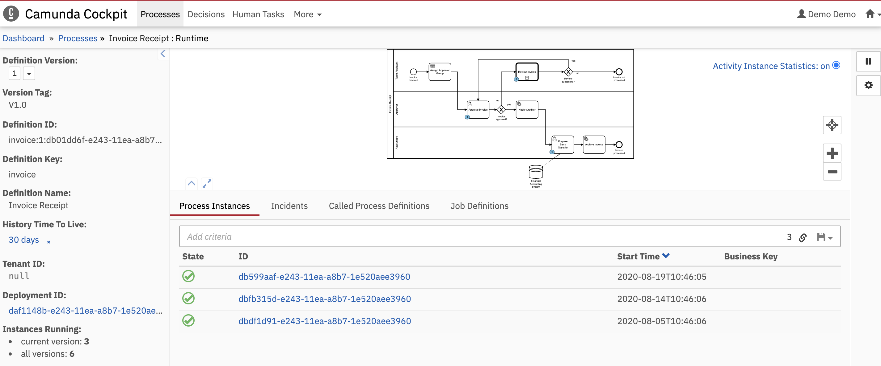
* You can see 3 process instances are created for process definition Invoice Receipt with version 1.

1. Detailed information for process instance can be accessed by clicking on id of particular process instance. Let click on id dc0d5a26-e243-11ea-a8b7-1e520aee3960

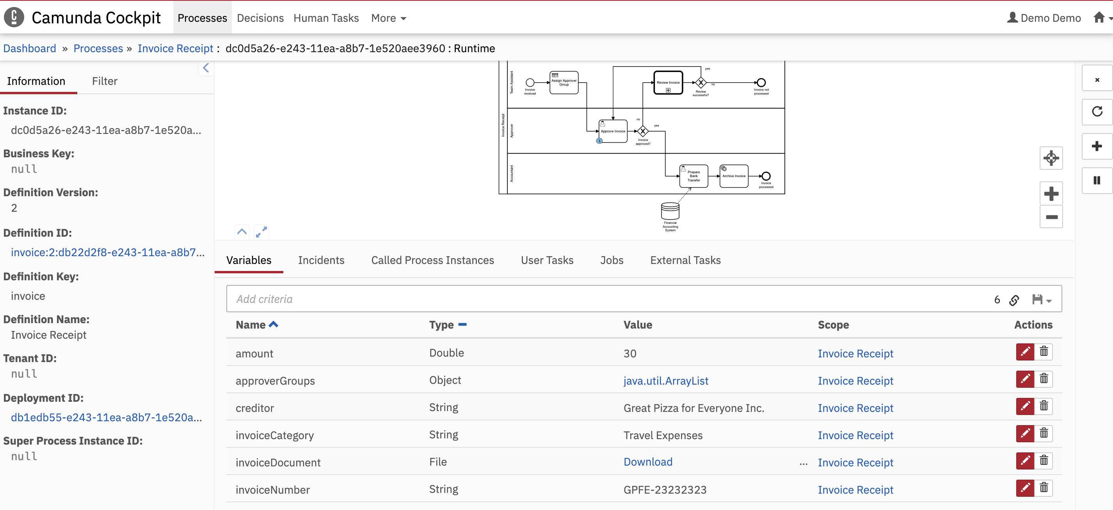

* **Variables:** Process instance variables with current value can monitored and edited or deleted by clicking on respective icons.
* **Called Process Instances:** List of the external sub process instances invoked from this parent process through call activity can be viewed.
* **User Tasks:** List of user task instances for current running process instance can be viewed.

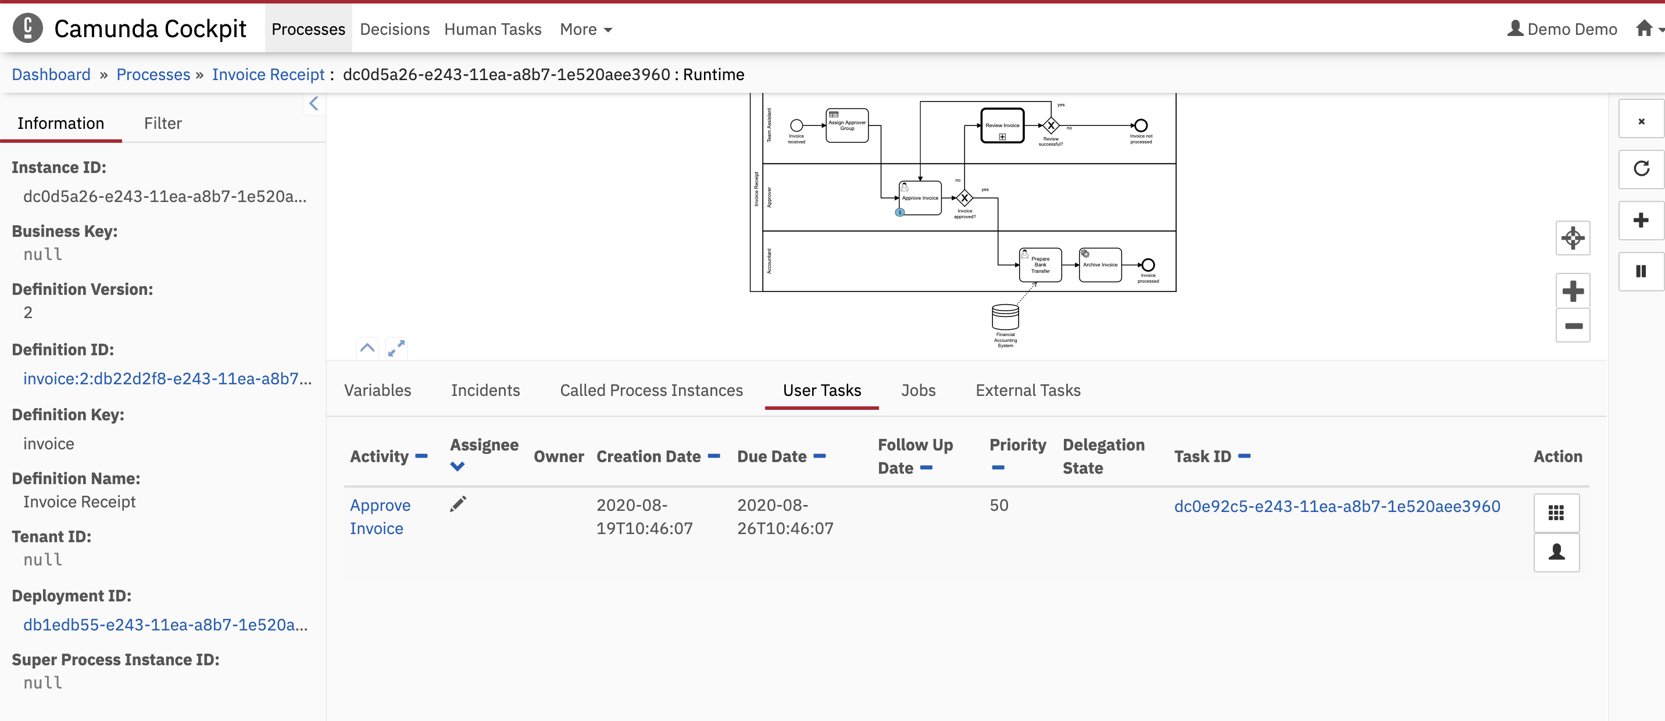

User task assignee can be change and you can also manage user for this task by adding users or removing added users by clicking icon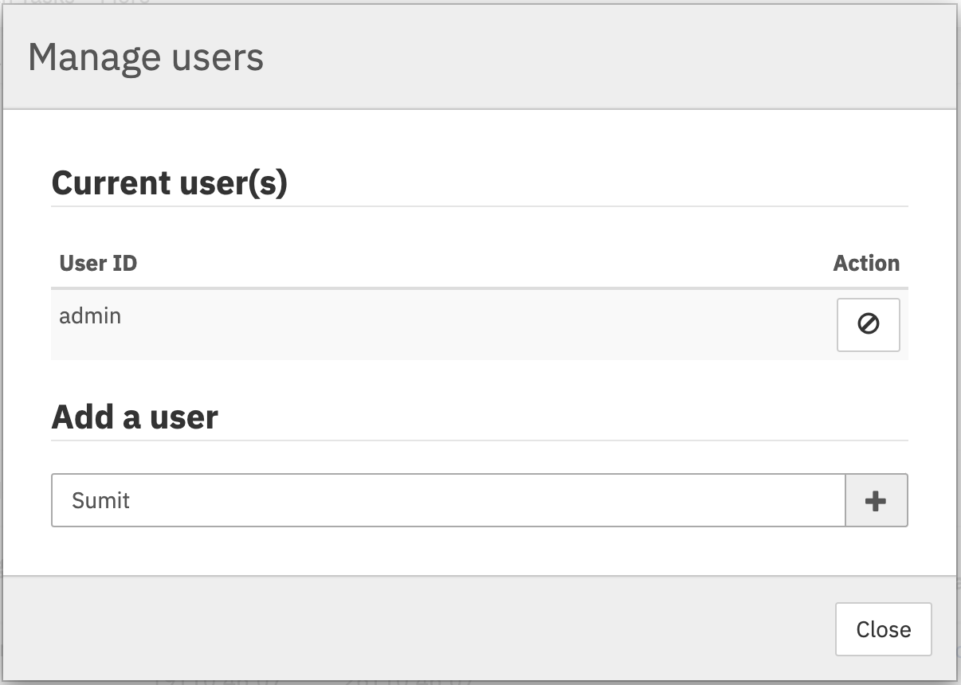

User task groups can be managed by adding users or removing or removing group users by clicking icon.

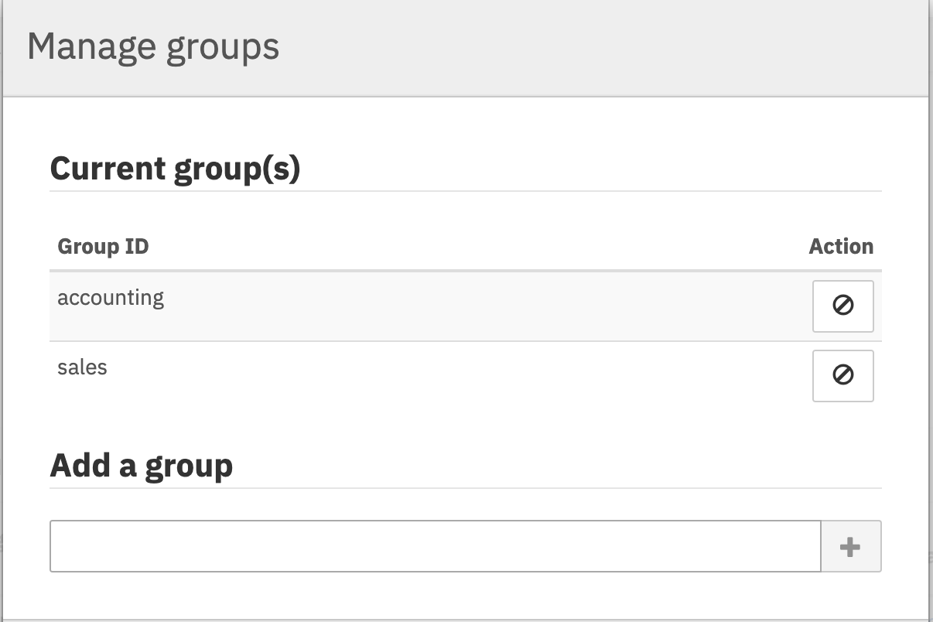

You can add new process instance variables, suspend or delete process instance.

Delete running process instance

Increment number of retries of failed job

Add new variable to process instance

Suspend process instance

* **Detailed view and edit decision instance**

1. Navigate to Decisions menu. 2 decision definitions are deployed.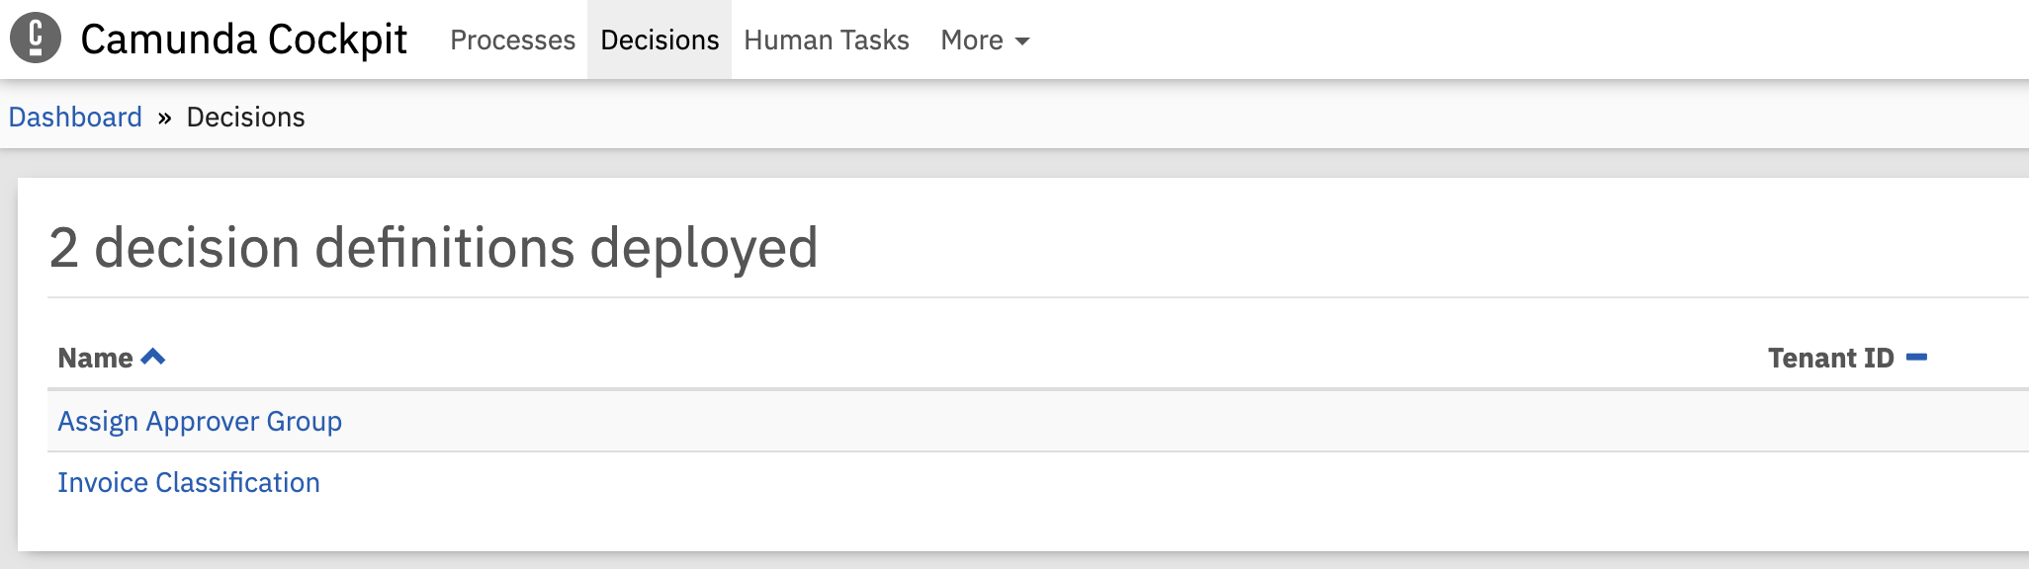
2. Click on Assign Approve Group decision definition.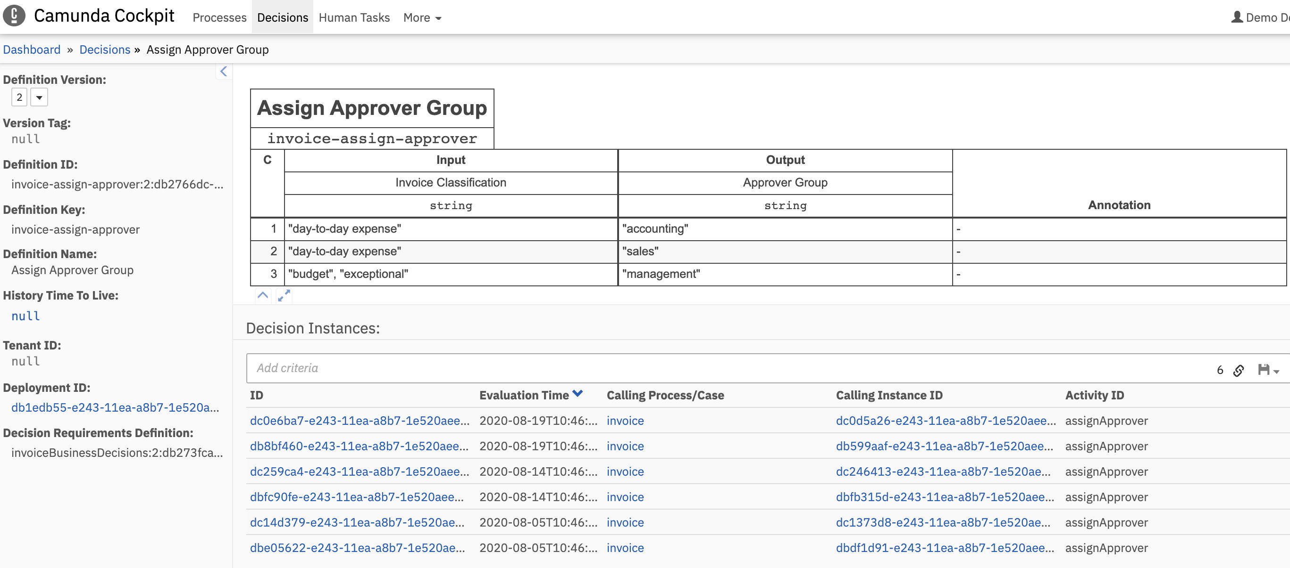

You can see decision table definition and instance created of decision table.

1. View decision table instance input and output.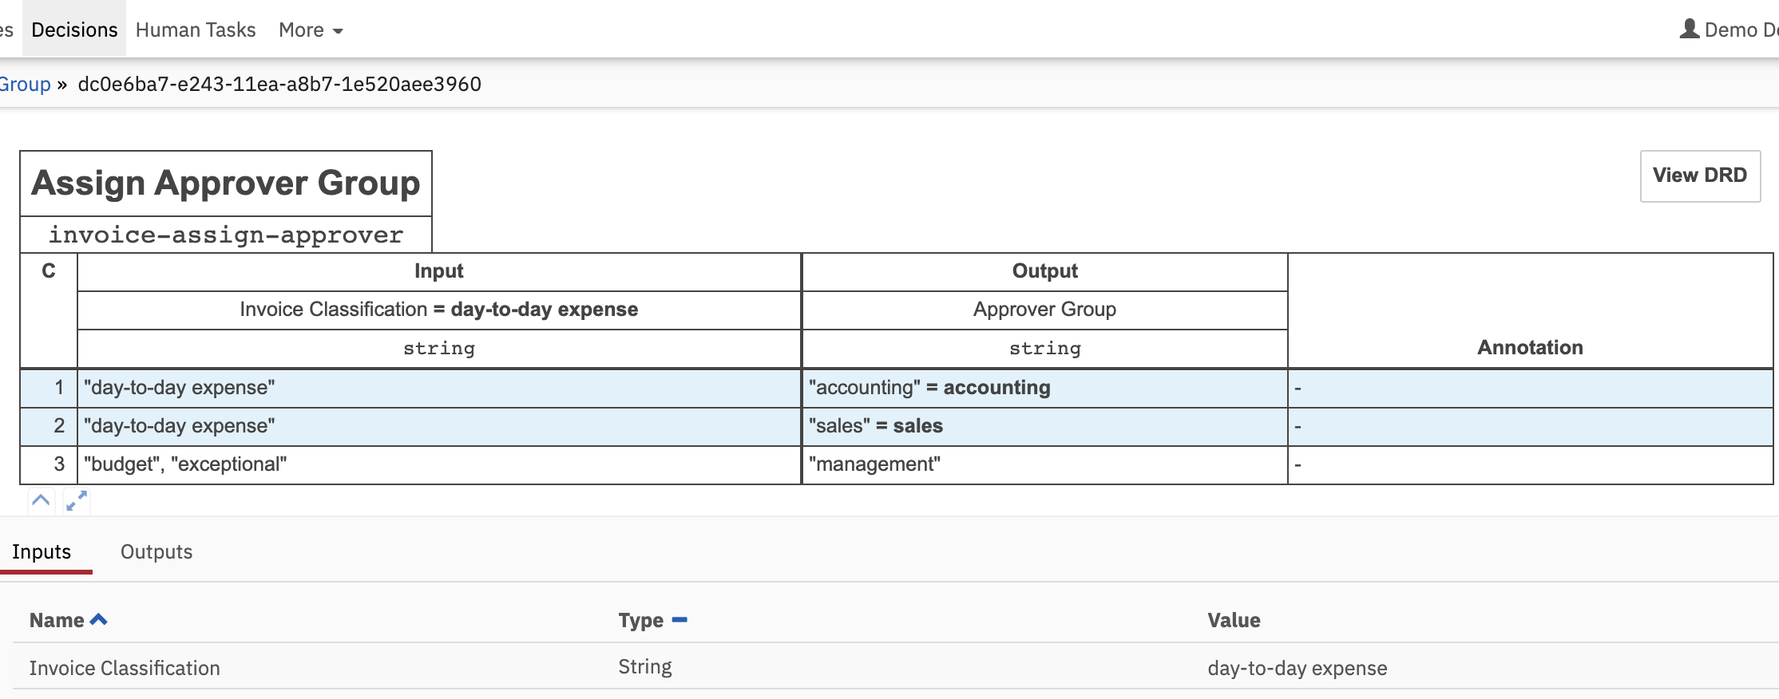

**Input :**

Invoice Classification = day-to-day-expense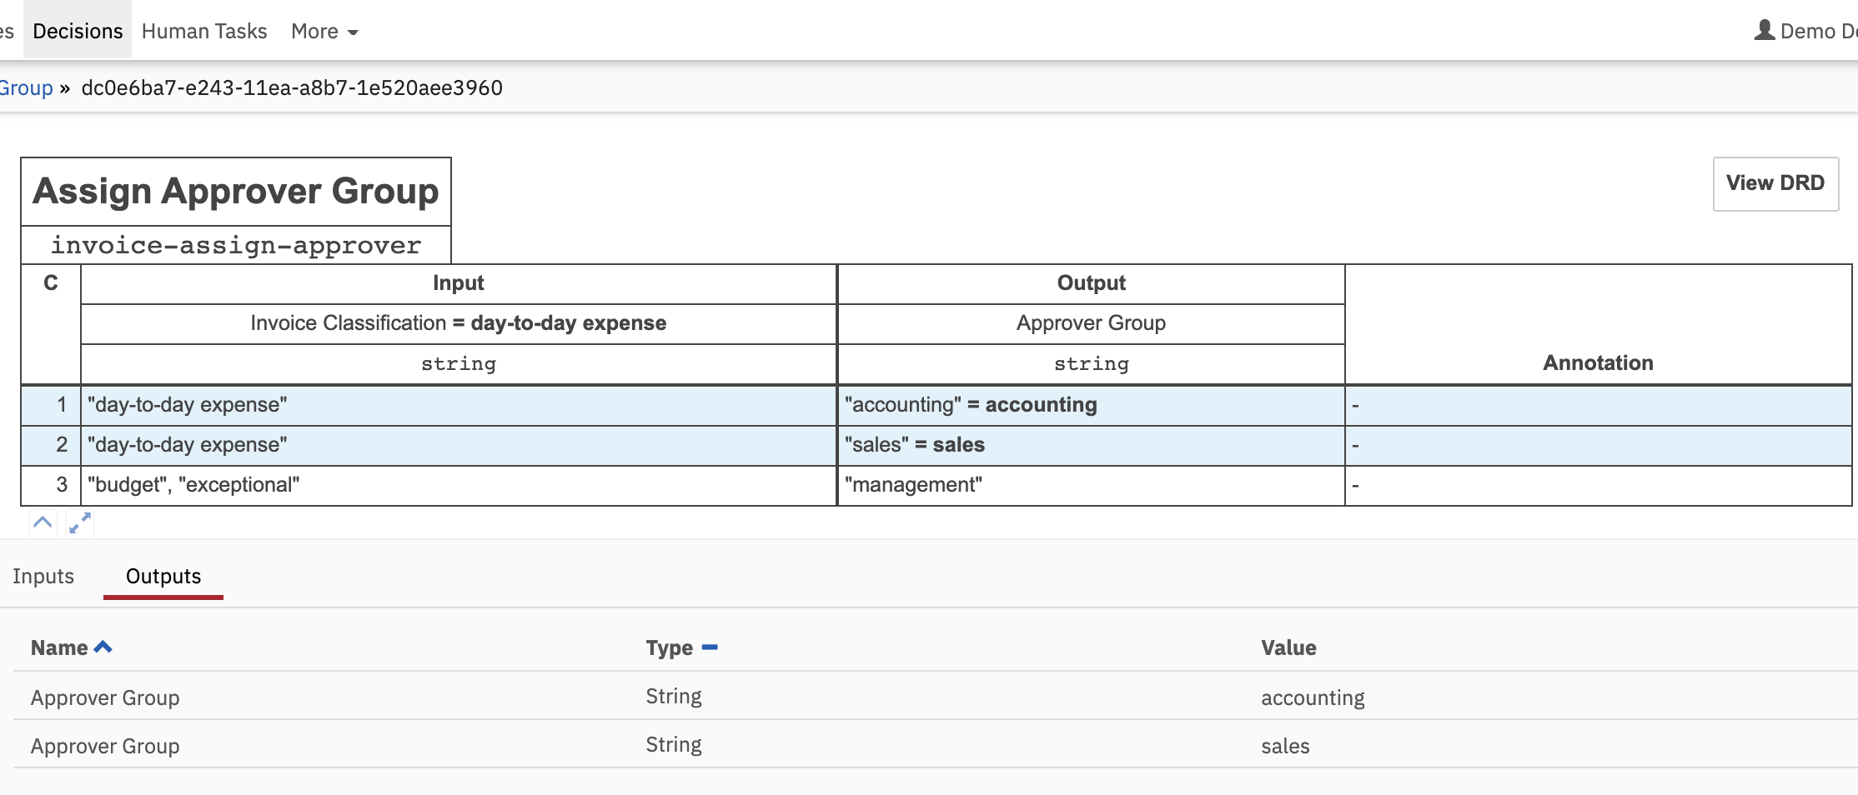

**Output :**

Definition table execution has produced multiple outputs for variable **Approve Group =** accounting, sales

* **Batches :**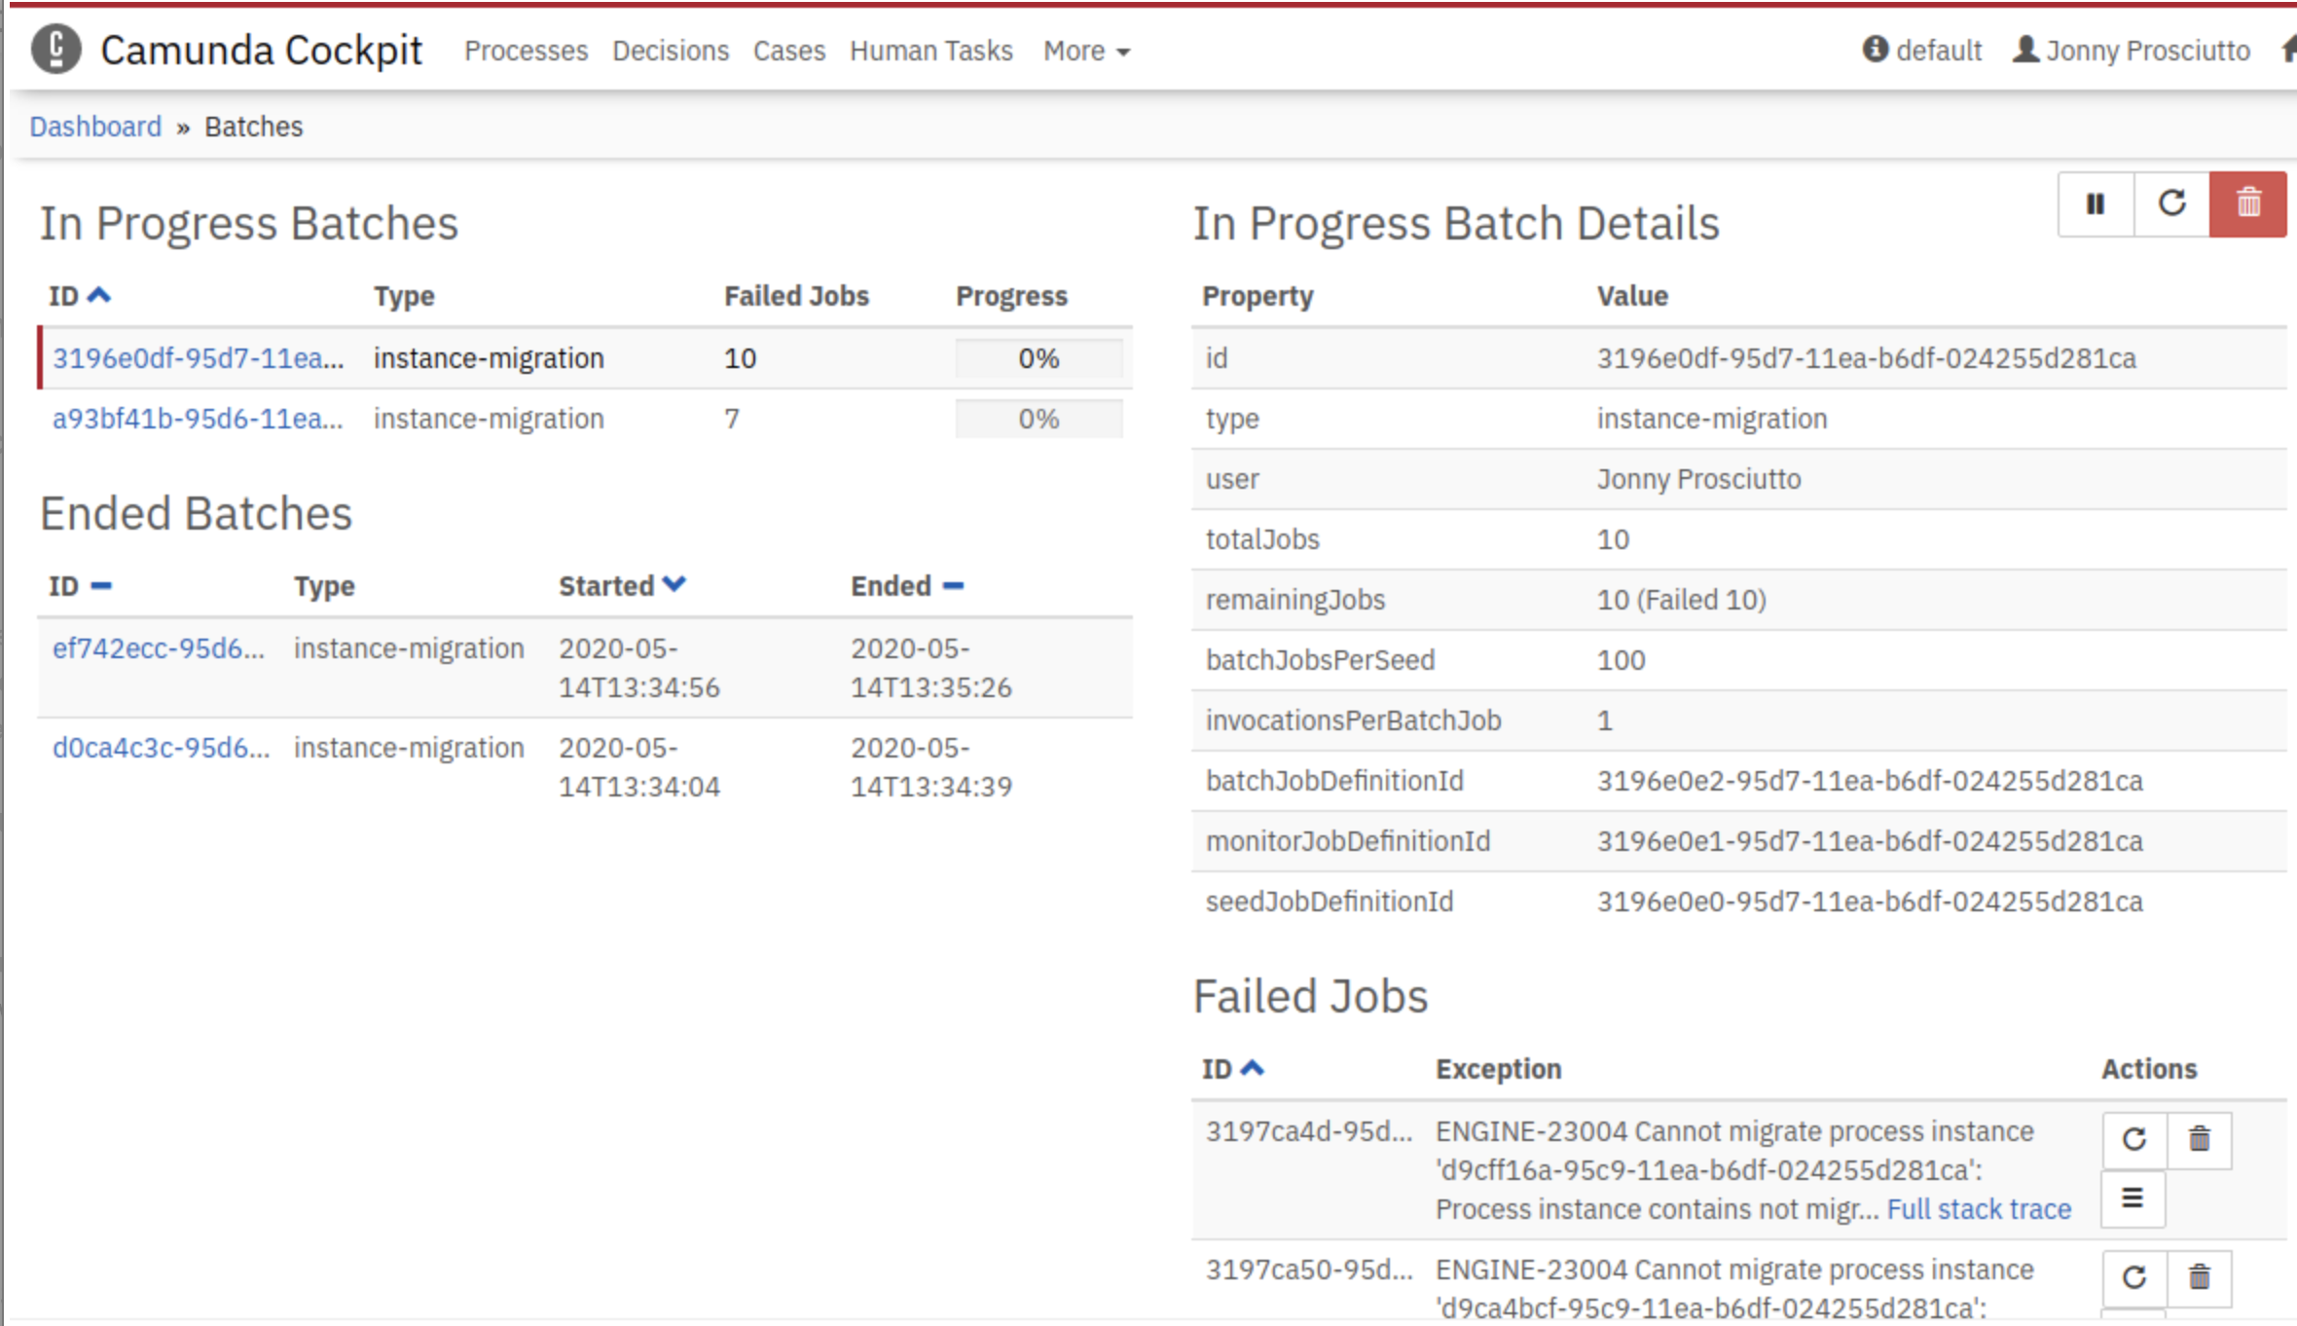

Batch is a concept to offload workload from the current execution to be processed in the background. This allows to run a process engine command asynchronously on a large set of instances without blocking.

For example the process instance migration command can be executed using a batch. This allows to migrate process instances asynchronously. A batch executes the migration in smaller chunks, each using a single transaction.

**Benefits:**

* asynchronous (non-blocking) execution
* execution can utilize multiple threads and job executors
* decoupling of execution, i.e., every batch execution job uses its own transaction

**Disadvantages:**

* manual polling for completion of the batch
* contention with other jobs executed by the process engine
* a batch can fail partially while a subset was already executed, e.g., some process instances were migrated where others failed

The batch utilizes the [job executor](https://docs.camunda.org/manual/7.6/user-guide/process-engine/the-job-executor/) of the process engine to execute the batch jobs. A single batch consists of three job types:

* **Seed job:** creates all batch execution jobs required to complete the batch
* **Execution jobs:** the actual execution of the batch command, e.g., the process instance migration
* **Monitor job:** after the seed job finished, it monitors the progress of the batch execution and completion

**Monitor batches:**

You can monitor in progress batches, ended batches, failed jobs for a batch.

A batch is created by executing a process engine command asynchronously.

Currently supported commands:

* Process Instance Migration
* Cancellation of running Process Instances
* Deletion of Historic Process Instances
* Setting retries of jobs associated with Process Instances